2019鄭芝龍國際學術研討會
鄭芝龍的海洋時代
International conference on Yquwn studies
SEA POWER OF YQUEN

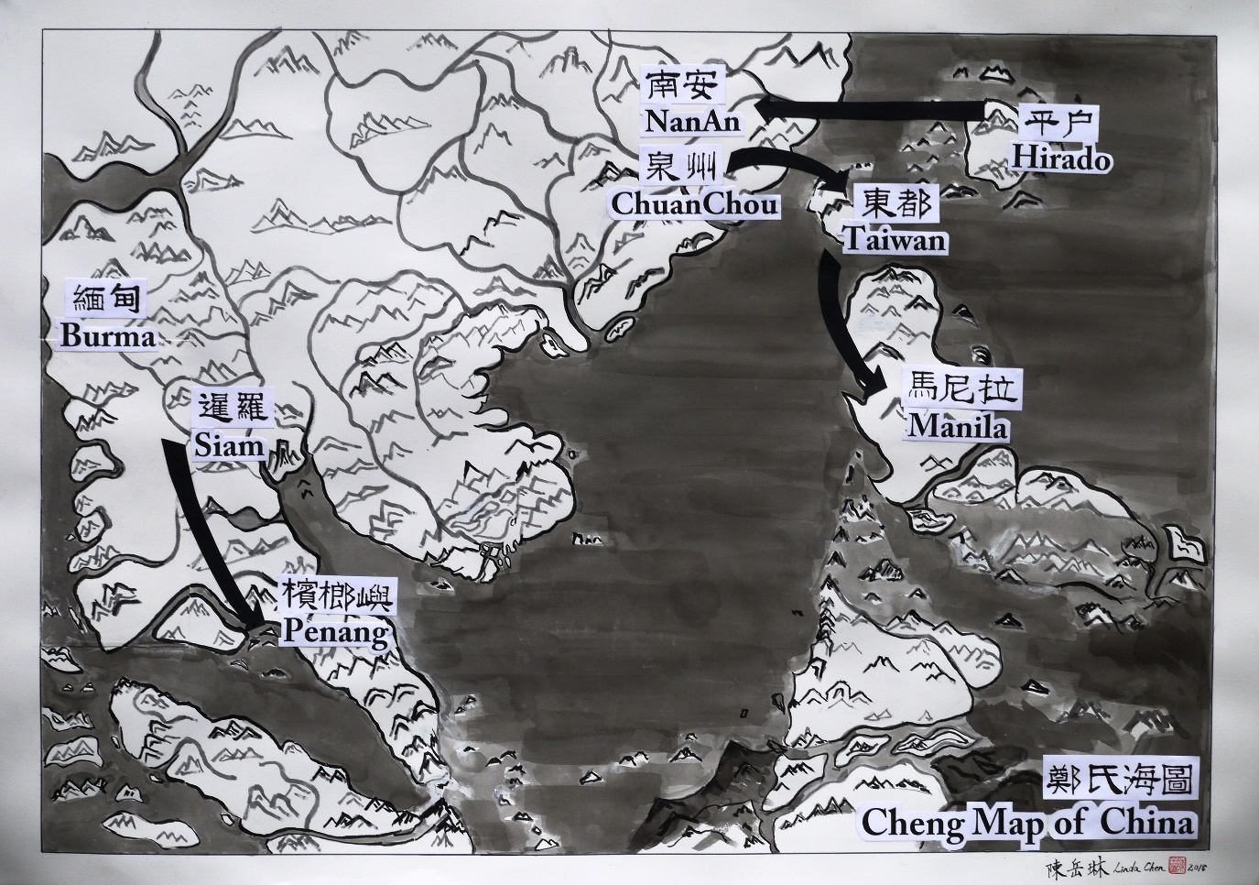

April 26-27, 2019
Tamkang University Chueh-sheng International Conference Hall (10th Fl.)

April 26, 2019(Friday)
Tamkang University Chueh-sheng International Conference Hall (10th Fl.)(淡江大學覺生國際會議中心)

9:30-9:40 Opening Session
鄭宏銘、鄭俊達

9:40-10:00 Group photography & Coffee Break

10:00-10:50 Keynote Speech
Chair & Discussant:周宗賢( Tamkang University)

陳國棟(Institute of History and Philology, Academia Sinica)

10:50-11:00 Coffee Break

11:00-11:50 Keynote Speech
Chair & Discussant:

Patrizia CARIOTI(University of Napoli)Zheng Zhilong's
International
Role in Maritime East Asia: Some Considerations and Remarks

11:50-13:00 Lunch

13:00-15:00 Chair & Discussant

Paola CALANCA (EFEO), Family survival strategy during the Zheng
regime and Ming-Qing dynastic transition conflicts
翁佳音(Institute of Taiwan History, Academia Sinica)

Emmanuel JOURDA()The broker who would be king
李毓中(National Tsing Hua University) 西班牙文獻中的鄭芝龍

15:00-15:20 Coffee Break

15:20-17:20 Chair & Discussant

陳國棟(Institute of History and Philology, Academia Sinica)
李廣超(Guangxi University of Finance and Economics) 論石井鄭氏家
族與鄭芝龍早期海洋活動探析
盧正恒(Emory University) 與國休戚：鄭芝龍在北京的生活、黨
爭、流放與死亡
Xing Hang(Brandeis University) 鄭氏對於十七世紀後半期華人在東
南亞的移民和開發的巨大影響

17:20-17:30 Closing ceremony

18:00 Dinner

